SIMATS ENGINEERING
ASSESSMENT TOOL 2

COURSE NAME: INTERNET PROGRAMMING
COURSE CODE: CSA43

COURSE OUTCOME COVERED

CO-1: Develop well-structured, standards-compliant web pages using HTML/XHTML and XML, and apply Internet protocols and HTTP communication mechanisms for web content delivery. (L2)

Assessment Tool : Data Interpretation

Weightage: 20%

QUESTIONS: Total Marks: 20

1: HTTP Response Analysis
A web server returns the following HTTP response header:
HTTP/1.1 200 OK
Date: Mon, 01 Apr 2026 10:00:00 GMT
Content-Type: text/html
Content-Length: -150
Connection: keep-alive
Questions:
- Identify any incorrect or invalid fields in the header.
- Analyze the issue with Content-Length and explain its impact.
- Determine whether the status code matches the response correctness.
- Suggest corrections for the identified errors.

2: DOM Structure Analysis
Consider the following DOM tree representation:
<html>
<head>
<title>Test Page</title>
</head>
<body>
<div>
<p>Hello World
</div>
</body>
</html>
Questions:
- Identify missing or improperly closed elements.
- Analyze how the browser will interpret this structure.
- Determine the impact on rendering and layout.
- Suggest corrections to make the DOM valid.

3: GET vs POST in Login System
A login system uses two different methods:
Method | URL Example | Data Visibility | Security Level
GET | /login?user=admin&pass=1234 | Visible in URL | Low
POST | /login | Hidden in body | Moderate
Questions:
- Interpret the differences in data transmission between GET and POST.
- Analyze which method is more suitable for login and why.
- Identify security risks in using GET for authentication.
- Suggest best practices for secure login implementation.

4: HTML Code Inspection
Analyze the following HTML snippet:
<!DOCTYPE html>
<html>
<head>
<title>Sample</title>
</head>
<body>
<h1>Welcome
<p>This is a paragraph
<img src="image.jpg">
</body>
</html>
Questions:
- Identify missing closing tags.
- Analyze issues with the <img> tag.
- Determine how browsers will handle these errors.
- Suggest a corrected version of the code.

5: Browser-Server Communication Flow
The following sequence describes a web request:
- User enters a URL in the browser
- DNS lookup occurs
- HTTP request is sent
- Server processes request
- Response is returned
- Browser renders page
Questions:
- Interpret each step in the communication flow.
- Identify where delays can occur.
- Analyze the role of DNS in the process.
- Suggest optimizations to improve performance.

Code of Conduct:

I K.Sushruth(192411073) certify that this submission is my original work and that I have adhered to the guidelines specified for this assessment.
I understand that any violation of academic integrity rules will result in disciplinary action.

Signature of the student: K.SUSHRUTH

CO1: Data Interpretation – Simple Answers

1. HTTP Response Analysis
Given HTTP response:
HTTP/1.1 200 OK
Date: Mon, 01 Apr 2026 10:00:00 GMT
Content-Type: text/html
Content-Length: -150
Connection: keep-alive

1. Identify incorrect or invalid fields.
- Content-Length: -150 is invalid because the content length cannot be negative.
- The date is incorrect because 1 April 2026 was a Wednesday, not Monday.

2. Explain the issue with Content-Length.
- Content-Length tells the size of the response body in bytes. A negative value is invalid and may cause the browser or server to handle the response incorrectly.

3. Does the status code match the response correctness?
- 200 OK means the request was successful. However, the response contains an invalid header, so the response is not completely correct.

4. Suggest corrections.
- Corrected header, assuming the response body contains 150 bytes:
HTTP/1.1 200 OK
Date: Wed, 01 Apr 2026 10:00:00 GMT
Content-Type: text/html
Content-Length: 150
Connection: keep-alive
- Conclusion: The content length must be a valid non-negative number, and the date must be correct.

2. DOM Structure Analysis
Given HTML:
<html>
<head>
<title>Test Page</title>
</head>
<body>
<div>
<p>Hello World
</div>
</body>
</html>

1. Identify missing or improperly closed elements.
- The closing tag </p> is missing for the paragraph element.

2. How will the browser interpret this structure?
- The browser will try to correct the error automatically. It will generally close the paragraph when it encounters </div> and display the text Hello World.

3. What is the impact on rendering and layout?
- The page will usually display correctly.
- The browser may automatically correct the HTML structure.
- Incorrect HTML can cause unexpected layouts and difficulties when using CSS or JavaScript.

4. Suggest corrections.
<!DOCTYPE html>
<html>
<head>
<title>Test Page</title>
</head>
<body>
<div>
<p>Hello World</p>
</div>
</body>
</html>
Conclusion: Closing all HTML elements properly helps the browser display the page correctly.

3. GET vs POST in Login System

1. Explain the differences between GET and POST.
<!DOCTYPE html>
<html>
<head>
<title>Login System</title>
</head>
<body>
<h2>GET Method</h2>
<form action="" method="GET">
Username: <input type="text" name="username"><br><br>
Password: <input type="password" name="password"><br><br>
<button type="submit">Login using GET</button>
</form>

<h2>POST Method</h2>
<form action="" method="POST">
Username: <input type="text" name="username"><br><br>
Password: <input type="password" name="password"><br><br>
<button type="submit">Login using POST</button>
</form>
</body>
</html>

2. Which method is suitable for login and why?
- The POST method is more suitable because the username and password are sent in the request body instead of appearing directly in the URL.
- However, POST alone does not provide encryption. HTTPS is also required.

3. What are the security risks of using GET for authentication?
- Passwords may appear in the browser history.
- Credentials may be stored in server logs.
- Other people may see the credentials in the URL.
- Sensitive information may be exposed through URL sharing or referrer information.

4. Suggest secure login practices.
- Use POST for login forms.
- Use HTTPS to protect data during transmission.
- Store passwords using secure password hashing.
- Validate login details on the server.
- Use secure session management.
- Limit repeated login attempts to prevent brute-force attacks.
- Conclusion: POST with HTTPS and proper password protection is recommended for secure login systems.

4. HTML Code Inspection
Given HTML:
<!DOCTYPE html>
<html>
<head>
<title>Sample</title>
</head>
<body>
<h1>Welcome
<p>This is a paragraph
<img src="image.jpg">
</body>
</html>

1. Identify missing closing tags.
- The missing closing tags are:
- </h1> for the heading.
- </p> for the paragraph.
- The <img> tag does not need a closing tag because it is a void element in HTML.

2. What are the issues with the <img> tag?
- The image tag is:
- <img src="image.jpg">
- It does not have an alt attribute.

- The image file must exist at the specified location.
- The image may not display if the file is missing.
- The alt attribute provides alternative text for users who cannot see the image.

3. How will the browser handle these errors?
- The browser will try to correct the missing closing tags and display the page. If the image file exists, it will display the image. Otherwise, a broken-image indicator may appear.

4. Write the corrected code.
<!DOCTYPE html>
<html>
<head>
<title>Sample</title>
</head>
<body>
<h1>Welcome</h1>
<p>This is a paragraph.</p>
<img src="image.jpg" alt="Sample image">
</body>
</html>
Conclusion: Correct HTML tags and a suitable alt attribute improve page structure and accessibility.

5. Browser–Server Communication Flow

<!DOCTYPE html>
<html>
<head>
<title>Browser Server Communication</title>
</head>
<body>
<h2>Browser–Server Communication Flow</h2>

<ol>
<li>User enters a URL in the browser.</li>
<li>DNS converts the domain name into an IP address.</li>
<li>Browser sends an HTTP request.</li>
<li>Server processes the request.</li>
<li>Server sends an HTTP response.</li>
<li>Browser displays the web page.</li>
</ol>

<button onclick="showMessage()">Test Communication Flow</button>

<p id="result"></p>

<script>
function showMessage() {
document.getElementById("result").innerHTML =
"Request sent! The browser displays this message.";
}
</script>
</body>
</html>

1. Explain each step in the communication flow.
- Step 1: User enters a URL
- The user enters a website address in the browser.
- Step 2: DNS lookup
- DNS converts the domain name into an IP address so the browser can locate the server.
- Step 3: HTTP request is sent
- The browser sends a request to the server to access the required web page.
- Step 4: Server processes the request
- The server processes the request and finds or generates the required information.
- Step 5: Response is returned
- The server sends a response containing a status code, headers, and possibly the requested content.
- Step 6: Browser renders the page
- The browser processes HTML, CSS, and JavaScript and displays the web page.

2. Where can delays occur?
- Delays may occur during:
- DNS lookup.

- Internet connection.
- Sending the request.
- Server processing.
- Downloading large files.
- Browser rendering.

3. Explain the role of DNS.
- DNS stands for Domain Name System. It converts website names into IP addresses.
- For example, it helps the browser find the server for example.com without requiring the user to remember its IP address.

4. Suggest ways to improve performance.
- Use DNS caching.
- Compress images and other files.
- Use a Content Delivery Network (CDN).
- Reduce unnecessary HTTP requests.
- Optimize server processing and database queries.
- Use browser caching.
- Compress responses using gzip or Brotli.
- Use HTTP/2 or HTTP/3 where supported.
- Conclusion: Efficient DNS, faster servers, smaller files, and browser caching help web pages load faster.

QN-1
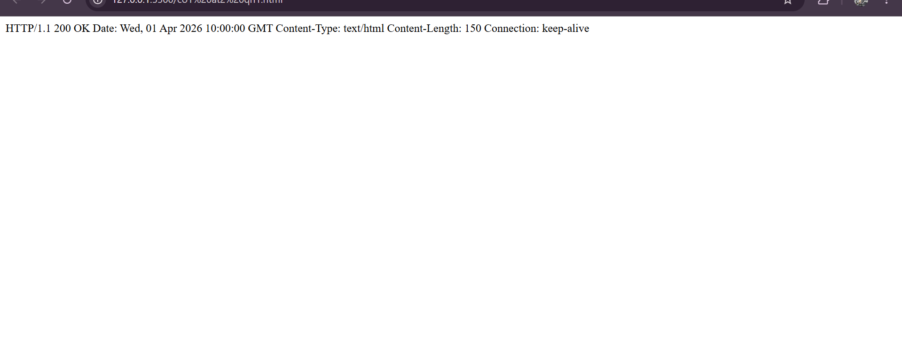

QN-2

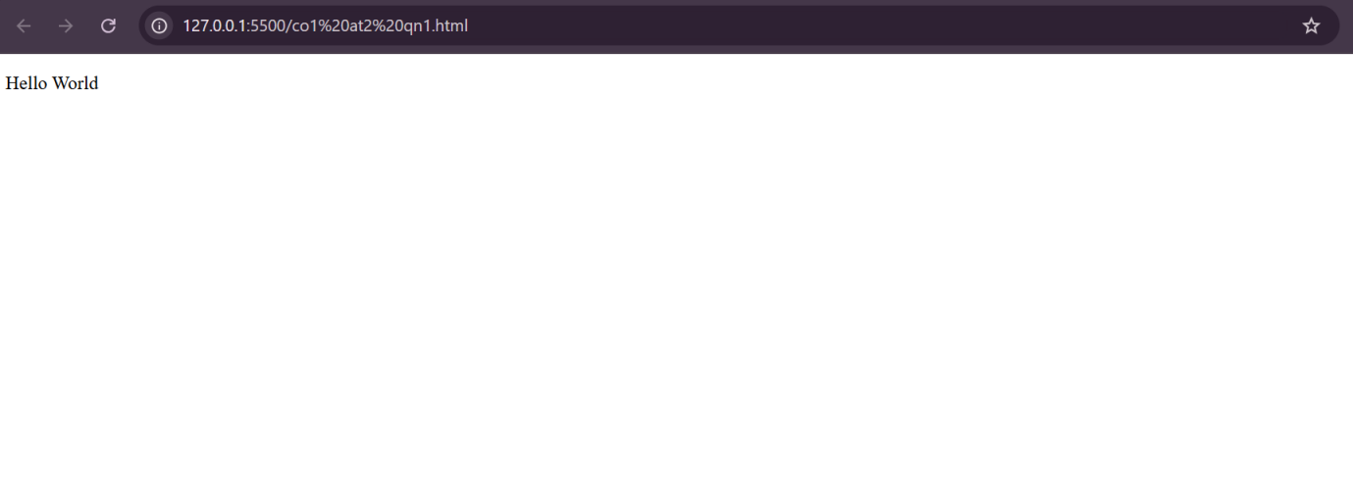

QN-3
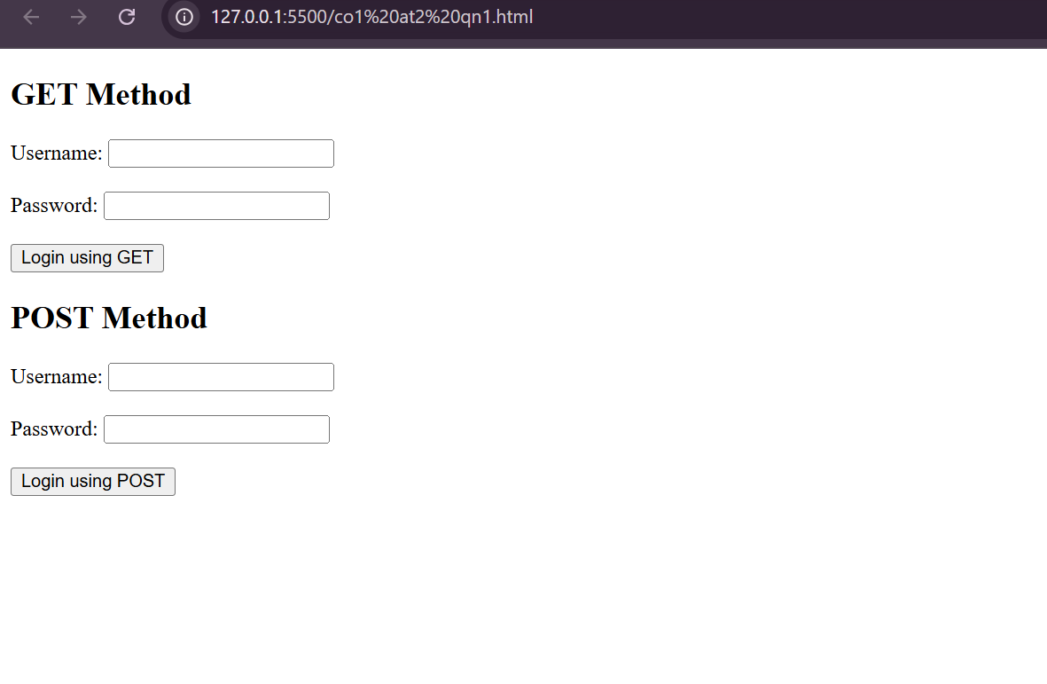

QN-4

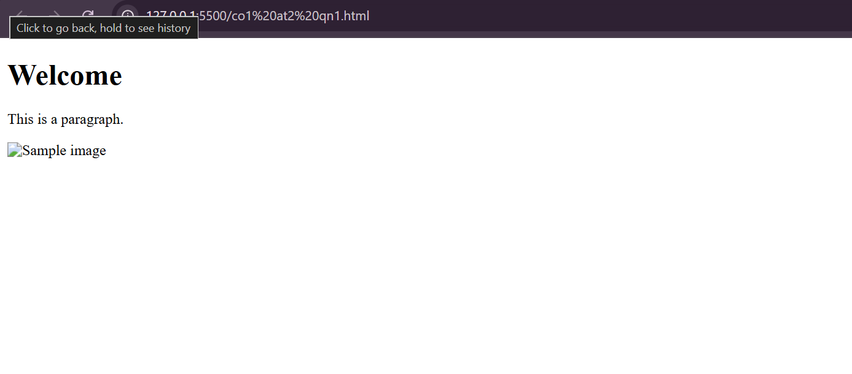

QN-5

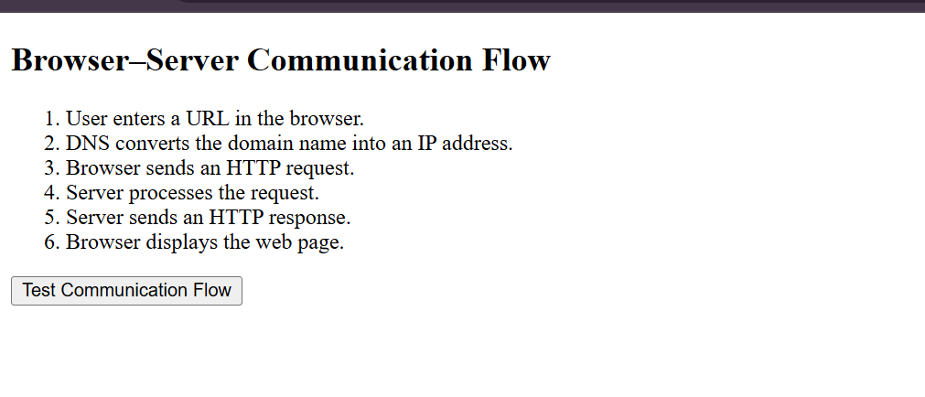

RUBRICS FOR CALCULATION:

Criteria | Weightage | Level 4 (Exemplary) | Level 3 (Proficient) | Level 2 (Developing) | Level 1 (Beginning)
Understanding of Data | 25% | Accurately interprets all data patterns, trends, and relationships | Interprets data correctly with minor gaps | Partial understanding; misses key trends | Misinterprets or fails to understand data
Analysis | 25% | Provides deep analysis with strong logical reasoning and justification | Provides reasonable analysis with some justification | Basic analysis with weak reasoning | No meaningful analysis provided
Application of Concepts | 20% | Effectively applies relevant concepts/tools to interpret data accurately | Applies concepts with minor errors | Limited application; requires guidance | Unable to apply concepts to data
Conclusion | 20% | Draws clear, meaningful conclusions with strong insights and implications | Provides valid conclusions with moderate insights | Conclusions are vague or weak | No clear or valid conclusions
Clarity | 10% | Presents interpretation clearly using proper structure, visuals, and terminology | Generally clear with minor issues | Lacks clarity or proper structure | Poor presentation and difficult to understand

